Fifa 2026 multiple linear regression predictive modelling
Introduction to the project
And that we will do two models
Please write something here a small paragraph.
Make sure that model1 results don’t spill on to next page- the pictures should be fixed in place

Model 1 Goal difference linear regression model

Variables
11 final variables chosen for to predict goal difference.
Each was differenced between the teams except for round number.
- Coach salary (this as indicative of an investment or a ‘drive’ within the team)
- Ranking (as recognised skill level)
- XG (expected goals calculated by expert statisticians)
- Median age (may indicate experience)
Caps – experience at international level. Grouped by position and averaged because teams differ in their makeup but only so many positions on the pitch at the same time)
- Goalkeeper Cap (level of experience at professional level. Not averaged because all teams have 3)
- Forward players mean Cap
- Defence player mean Cap
- Midfield player mean Cap
Goals – by players at international level
- Forward player mean Goals
- Squad goal rate (goals divided by caps)
- Round number (categorised from 1-8)

Data sources
https://worldcupstats.football/teams/#sort=delta_points%2Cdesc Team ranking at 1/04/2026
https://www.salaryleaks.com/blogs/world-cup-2026-coach-salary-rankings Coach estimated annual salary at 12/06/2026
https://fdp.fifa.org/assetspublic/ce281/pdf/SquadLists-English.pdf
https://en.wikipedia.org/wiki/2026_FIFA_World_Cup_squads# Final squad stats 2/06/2026 caps, goals, players, DOB. PDF imported and cleaned in excel
https://www.thestatsdontlie.com/football/world-cup-2026/ Expected goals per match extracted from frame info embedded google sheet
https://theanalyst.com/articles/france-vs-england-stats-world-cup-2026-bronze- Expected goal for the third place final (not listed on statsdontlie)

Methods

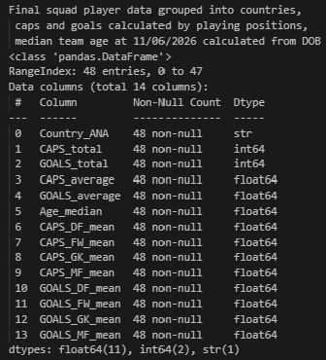
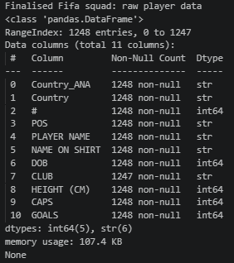
Once the variables were decided on and the data located, the data was loaded into excel for cleaning and collating. Raw player data was grouped and categorised in python(figures1,2) before exporting back to excel to finalise the linear regression datasheet (figure 3). Initial testing used 11 variables. After evaluating model power and correlation (figure 4), this number was reduced to 8 by removing the variables with least relationship to actual goal difference. Surprisingly that included squad goal rate, midfield and defence caps.
Figure 1 Raw player dataset
Figure 2 Squad dataset from player data
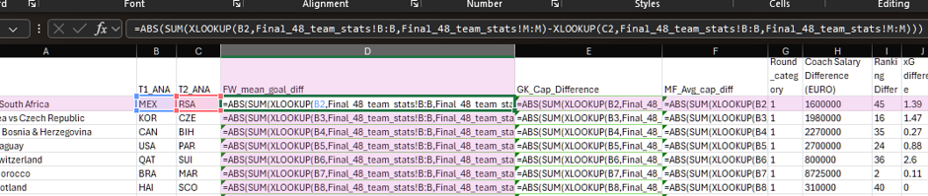
Figure 3 Data wrangling in excel

Results
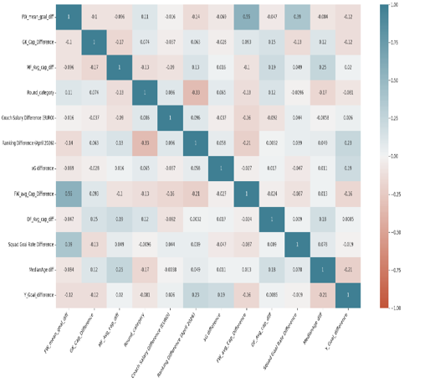
Multiple scalers were tried in Python to find best fit for modelling but there appeared to be no strong linear correlations in the dataset. Scikit-Learn linear regression with StandardScaler and K-fold validation performed very poorly with negative results (figure 6) but at least better than Baseline modelling (figure 7). The best combination was Statsmodel package with PowerTransform scaler. With an adjusted R² = .1, this model can explain 10% of results.
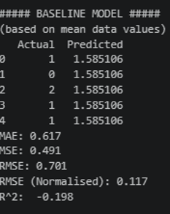
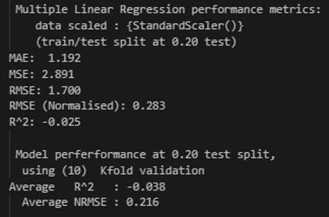
< Figure 4 Correlation heatmap-11 variables
^ Figure 5 Skicit-learn model performance metrics
>Figure 6 Baseline performance metrics

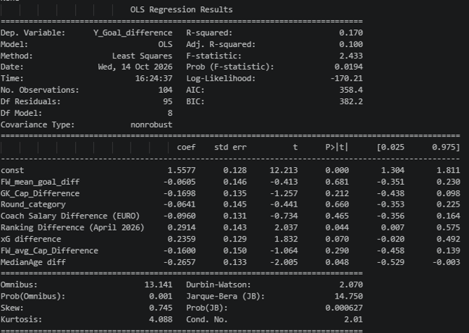
< Figure 7 Multiple linear regression summary after power transformation

Conclusion
These variables not very effective at predicting goal difference. I believe this could be improved upon using different statistics. This process has illustrated the important of accessing expert knowledge and doing rigorous research to choose appropriate explanatory variables.

